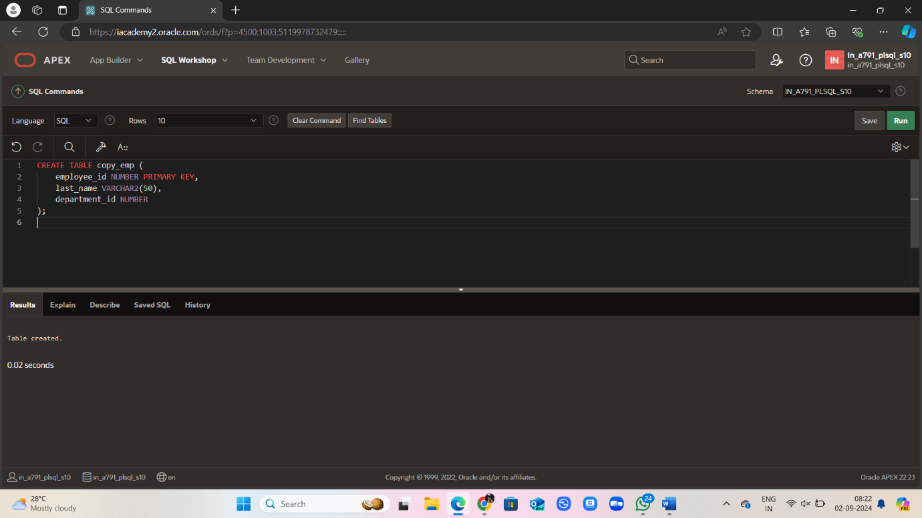

CREATE TABLE employees24 (

employee_id NUMBER PRIMARY KEY,

last_name VARCHAR2(50),

department_id NUMBER

);

CREATE TABLE copy_emp (

employee_id NUMBER PRIMARY KEY,

last_name VARCHAR2(50),

department_id NUMBER

);

INSERT INTO employees24 (employee_id, last_name, department_id) VALUES (1, 'Smith', 101);

INSERT INTO employees24 (employee_id, last_name, department_id) VALUES (2, 'Jones', 102);

INSERT INTO employees24(employee_id, last_name, department_id) VALUES (3, 'Taylor', 103);

INSERT INTO copy_emp (employee_id, last_name, department_id) VALUES (1, 'Smith', 100);

INSERT INTO copy_emp (employee_id, last_name, department_id) VALUES (4, 'Brown', 104);

MERGE INTO copy_emp c USING employees14- e

ON (c.employee_id = e.employee_id)

WHEN MATCHED THEN UPDATE

SET

c.last_name = e.last_name,

c.department_id = e.department_id

WHEN NOT MATCHED THEN INSERT

VALUES (e.employee_id, e.last_name, e.department_id);

